📘 SCV – Symbiotic Creation & Validation
Turning fuzzy ideas into reliable results with AI

Chapter 1 — Why SCV, who it is for, and how to visualise it

The paradox of “magical” AI
We are living through a strange period
On the one hand, generative AI is impressing everyone. In a matter of seconds, it drafts texts, summarises documents, generates ideas, and proposes action plans.
On the other hand, organisations are struggling to get anything stable, repeatable, or serious out of it.
You may already have heard these phrases:
- I got an incredible answer yesterday, but I can’t remember how I phrased my request…
- When I use it, it gives me rubbish. How do you do it?
- We’re not allowed to base a serious decision on that, it’s still just AI ‘blah-blah’…
- If Sophie leaves, we lose everything she does with AI — she’s the one who ‘has the knack’
This book starts from a simple observation: as long as human–AI collaboration remains improvised, it cannot become a genuine strategic advantage.
The purpose of SCV is to move beyond this permanent tinkering.

Four structural problems

Improvised interactions, unstable results
Today, most interactions with an LLM look like this:
- You open a new conversation
- You “throw in” a request
- You read the answer
- You adjust by feel
Sometimes it works
Often, we do not know why.
There is:
- no clear mandate
- no success criteria
- no usable record of decisions

We confuse “having a good instinct for prompting” with “mastering a system”.

Cognitive overload: we test instead of design
Every new request to AI creates a micro-mental load:
- How to phrase it
- What to specify
- Which examples to provide
- What to correct in the answer

You are using your energy to manage the conversation, instead of using it to:
- clarify your intention
- define success criteria
- orchestrate a system
The result is fatigue.
AI is supposed to help us, but day to day it forces us to “think for it” all the time.

Inability to reproduce what works
Without a framework, everything depends on individuals:
- the person who is good at handling AI
- the good prompts saved somewhere
- the little tricks nobody ever took the time to explain
As soon as someone changes role or leaves the organisation, part of the AI practices disappears with them.

At team level, this creates an absurd situation:
- some people feel that AI is a powerful lever
- others think it is an inconsistent gadget

The truth: the latter are not less capable.
They are simply operating in an environment with no structure.

Good results do not survive change
Even when an AI flow works well, it is fragile:
- change of model (new version of the LLM)
- change of language (switching from French to English)
- change of context (new target, new market)
- change of team (different uses, different constraints)
Without making the choices, assumptions, and decisions explicit, performance depends on invisible conditions.
At the slightest change, everything has to be redone.

Who is this book for?
➡ This book is for you if:
- you are a knowledge worker (consultant, analyst, trainer, project manager, manager, etc.) and you are already using AI… but you feel that everything still relies on improvisation
- you are a solopreneur or independent professional, and you want to turn AI into a production system rather than a simple occasional assistant
- you lead an operational team or a support function, and you are looking for a traceable and governable way to integrate AI into processes
- you are a decision-maker, and you refuse to entrust serious decisions to a non-auditable “black box”
This book is not for you if:
- you are looking for a collection of “magical prompts”
- you hope to automate humans rather than augment them
- you want to do AI research at model level (this book is not about neural network architectures, but about workflows)

S1 entry points: accepting the reality of ideas.
In reality, initial ideas are almost never neat or well-formulated. They may be a voice memo recorded on the go, a photo of a whiteboard, a scanned handwritten note, or three sentences dropped into a chat after a meeting.
SCV treats all these forms as valid entry points: whatever the channel or format, as long as the idea can be brought into the flow. What matters is getting the idea out of the human mind and into a space where it can be worked on.
This is an important shift in posture:
- You no longer need to wait until you have the time
- You no longer need to “phrase it well” before starting
- You no longer lose an idea simply because it emerged at the wrong moment

We will see in the chapter on S1 how to organise this capture in practical terms.

The gold rush metaphor
Imagine the gold rush.
- The prospectors are your colleagues, your freelancers, yourself
- The gold is the useful results: robust procedures, better decisions, learning content, structured offers
- The powerful machines are the LLMs: they can move mountains of information in record time
- The ground is your data, your processes, your constraints, your clients

In this landscape, most players rush in enthusiastically… and simply dig a little everywhere.
SCV is not selling you one more pickaxe.
SCV is the operating method:
- where to dig
- in what order
- with which tools
- under which rules
- how to document what you find
If you develop a tool that implements SCV (as a specialised platform such as Pinpoint might do), your positioning becomes that of a manufacturer of custom shovels for this AI gold rush.

The common thread: Julie’s onboarding.
To make this book concrete, we will follow the same example throughout the chapters.
A small service business, 100% remote.
A new employee, Julie.
A manager who has had enough of improvised onboarding.
Her initial intention is simple:
“I want an onboarding procedure that is clear, reusable, and flexible enough to adapt to different profiles.”
We will see, chapter by chapter, how this intention passes through:
- S1 — an idea captured on the fly
- S2 — a structured mandate
- S3 — a concrete onboarding procedure
- S4 — a test across several scenarios
- S5 — a capitalised version 1.0, then an improved one

Along the way, you will discover:
- how to separate the LLM from the decision agent
- how to document everything in an SCV-Ledger
- how to apply the same logic to your own cases (sales, quality, training, product, etc.)

Chapter 2 — Definition of the SCV flow
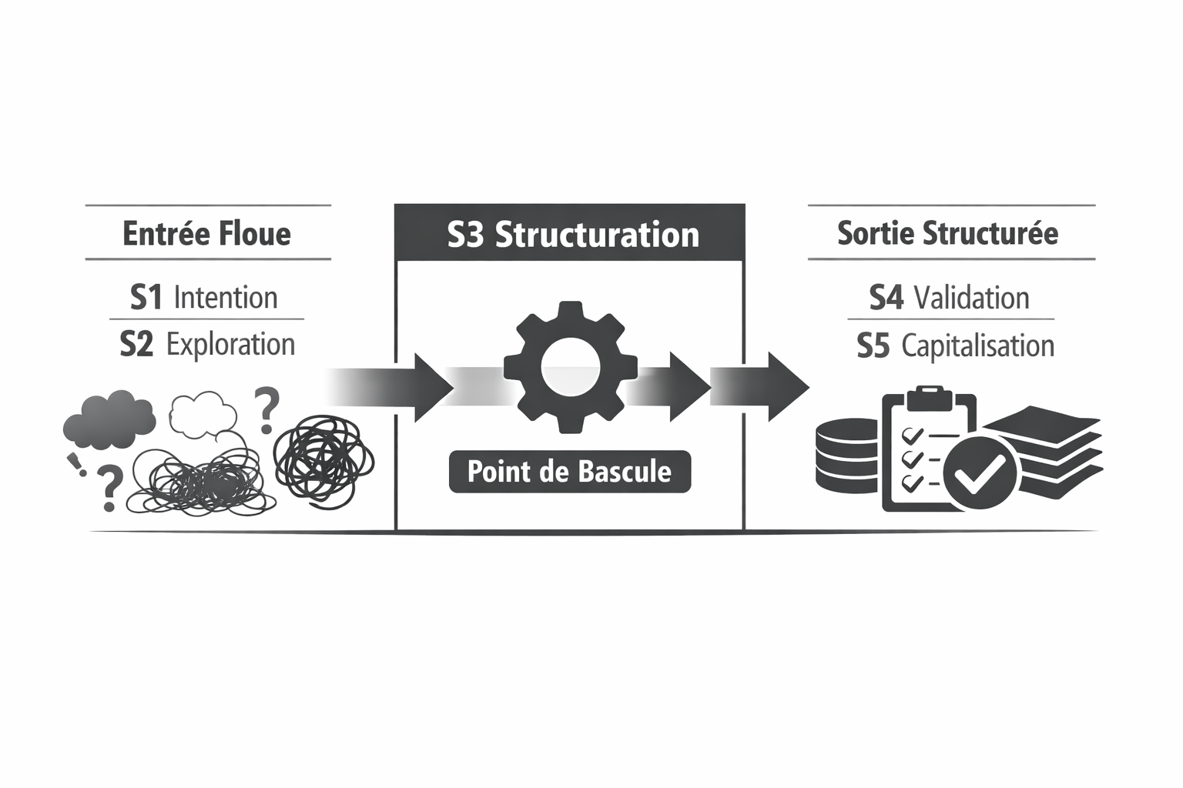

The short definition
SCV is a method for turning a fuzzy idea into a clear, validated, and reusable result through structured collaboration between a human and specialised AI agents.

Three elements are essential:
- Fuzzy idea: you do not need to know exactly what to produce
- Clear, validated, reusable result: the goal is not a “nice answer”, but a usable artefact
- Structured collaboration: the process matters just as much as the result
.

The long definition, broken down

Let us break it down into four building blocks:

Block 1: Human intention
Everything begins with an intention, however vague:
- We want to professionalise our onboarding
- We need to decide how to prioritise our prospects
- We would like to turn our training into hybrid modules

In a conventional use of AI, this intention is turned directly into a prompt.
In SCV, this intention passes through:
- a capture (S1)
- structured clarification (S2)
- a formal mandate (a “contract” between the human and the system)

This stage is central: as long as the intention remains vague, you cannot judge whether the result is good or not.

Block 2: Structuring through specialised AI agents
SCV does not rely on one generic “AI”, but on a constellation of agents, each specialised in a role:
- co-structuring agent (S2)
- co-creation agent (S3)
- validation agent (S4)
- capitalisation agent (S5)
- explanation agent (LLM interface)
These agents can be implemented in a single tool, but conceptually their roles are distinct.
This structuring makes it possible to:
- clarify who does what (human vs AI)
- reduce cognitive load
- make flows more predictable

Block 3: Explicit validation
SCV rejects the idea that “it looks good” is enough.
Validation is a stage in its own right, with:
- test scenarios
- success criteria
- a status (validated, validated with reservations, rejected)
- a record in the ledger
Without explicit validation, we confuse plausibility with reliability.

Block 4: Capitalisation in a ledger
Each pass through the SCV flow produces:
- an artefact
- decisions
- learnings
All of this is recorded in a ledger:
- a chronological log by SCV ID
- linking S1 → S2 → S3 → S4 → S5
- and allowing you to trace the chain of decisions
It is this ledger that turns SCV into a governance tool rather than a simple productivity recipe.

Why SCV is not “just better-written prompts”
One might think that SCV consists of “writing better, more structured prompts”.
In reality, the difference lies elsewhere:
- a prompt is an instruction sent to a model
- an SCV flow is a production system including:
  - intentions
  - mandates
  - artefacts
  - validations
  - logs
A good test:
if you remove the AI model, what remains?
- with isolated prompts: almost nothing
- with SCV: documented decisions, procedures, validation frameworks, decision tables, a memory

Why “symbiotic”?
We speak of Symbiotic Creation & Validation because:
- humans and AI are interdependent
- each brings what the other does not have
- the system is viable only if both cooperate

The human:
- defines meaning, context, and stakes
- arbitrates, decides, takes responsibility
- corrects the course
AI:
- proposes structures
- generates variations
- summarises, compares, reformulates
Without humans, SCV becomes a sophisticated text generator.
Without AI, SCV becomes a somewhat heavy project management methodology.
Together, they form a robust flow.

Chapter 3 — Overview of the five stages of SCV

Before going into the detail of each stage, let us take an overview through the lens of our common thread: Julie’s onboarding.

S1 — Symbiotic capture of ideas.
The manager comes home after a busy day. He thinks:
“We keep forgetting things in onboarding. We need to stop improvising.”
On the way, he records a 45-second voice memo.
This memo becomes entry SCV-2025-11-20-0001
We will see in Chapter 4:
- how to organise this capture
- how to reduce friction as much as possible
- which formats to accept

S2 — Co-Structuring
A co-structuring agent reads this transcribed memo and begins a brief dialogue:
- What employee profiles are involved?
- Which tools do you use?
- How often do you have onboardings?
- What are the main stakes (time, quality, image, risk)?
From these elements, it builds an S2 mandate.
The manager validates it. S2 ends there.
We will see in Chapter 5 how to build these mandates effectively.

S3 — Co-Creation
Based on the S2 mandate:
- a co-creation agent generates two versions of the procedure
  - A: highly structured, checklist-oriented
  - B: more narrative, pedagogy-oriented
- it adds a summary in English
- it adds SCV metadata
The manager comments and asks for a combined version.
This version becomes the testable prototype.
We will go through all of this in detail in Chapter 6.

S4 — Validation
A validation agent tests the procedure across three scenarios:
- Julie, an experienced employee but new to the company
- A rushed manager with very little time
- A junior profile, not very used to remote work
Two weaknesses emerge:
- first day overloaded
- unclear responsibilities
Adjustments are proposed and integrated, and the version moves to “validated_pro”.
We will see in Chapter 7 how to systematise this validation.

S5 — Capitalisation and iteration
The validated procedure is:
- stored in a shared repository
- given a version identifier (v1.0)
- documented in a clear space
After 30 days, field feedback shows:
- recurring omissions in access provisioning
- a lack of mentoring
This feedback is entered into the ledger and opens a new S1 for V2.
Chapter 8 will detail this loop.

The SCV loop as the “skeleton” of your AI projects
For every serious AI project, you can ask yourself:
- Where is S1? (The raw idea — captured where, and how?)
- Where is S2? (The mandate — clarified where, validated by whom?)
- Where is S3? (The versions, the trade-offs?)
- Where is S4? (The test scenarios, the final status?)
- Where is S5? (The memory, the feedback, the next iteration?)
If you cannot find the answer to one of these questions, that is probably where your flow is breaking today.

SCV as a factory of multilingual “shovels”
In practice, each SCV flow can produce very different artefacts: operational procedures, specialised prompts, AI agents dedicated to a task, training modules, decision tables, prioritisation matrices, and so on. In other words, SCV is not just an abstract method of thinking: it is also a factory of concrete “shovels” for your AI projects.
This becomes particularly interesting when you work in several languages. For example, you can:
- capture a process improvement idea in French (S1)
- co-structure the mandate in English with an international team (S2)
- co-create a bilingual FR/EN artefact in S3 (procedure, script, training module)
- document the key decisions and the procedure summary in Spanish in your knowledge base (S5)
The flow remains exactly the same; only the linguistic content varies. That is what makes SCV a naturally multilingual framework, rather than a simple “single-language + translation at the end” method.

Chapter 4 — S1: Symbiotic capture of ideas

The real role of S1
S1 is the universal inbox: everything that goes through your mind, however fuzzy, must be able to land here.
The purpose of S1 is not to “think well”.
The purpose of S1 is to avoid losses.
A good S1:
- accepts that the human may be rushed, scattered, sometimes confused
- absorbs all forms of signals
- turns them into usable material for what comes next

Possible formats for the fuzzy idea
In practice, for S1 to work, what you really need to decide is which formats you accept without debate.
To simplify, consider that anything containing a fragment of an idea is acceptable in S1:
- text typed quickly into a notes app
- a voice memo (which the AI transcribes automatically)
- a photo of a whiteboard or a handwritten note
- a screenshot
- an email or conversation extract (Slack, Teams, etc.)
What matters is not “writing well”, but marking the entry point: as soon as something deserves to be reworked later with AI, it must be able to land in S1 with an SCV ID.
In practical terms, your rule can become:
“As soon as an idea touches a process, a decision, a recurring document, or an improvement opportunity, I place it in S1, even if it is raw and incomplete.”

Mini-example S1 (integrated literally)
In reality, ideas are not born as neatly structured Word documents. In our example, the company manager has neither the time nor the energy to “write a perfect request”. One evening, after a busy day, he opens the notes app on his phone and records a 45-second voice memo:
“We’ve got another new employee arriving next week. It’s the third time in a row we’ve forgotten important things. I want a simple onboarding procedure for remote work that covers access, tools, meeting the team, and expectations for the first 30 days. Something any manager could follow, even if they’re rushed.”
The voice memo is transcribed automatically, imperfections included. The AI places it in the S1 inbox with the identifier:
SCV-2025-11-20-0001
The idea now exists in the system. S1 is complete.

How to set up S1 in your organisation

Step 1 — Choose a main channel
Decide where all S1 ideas land.
A few options:
- a dedicated email address (scv@yourcompany.com)
- a Notion form or Google Form
- a space in your task management tool
- a notes app synchronised with an AI agent
What matters is limiting channels.
One imperfect but centralised channel is better than five ideal but scattered channels.

Step 2 — Define a standard identifier
Adopt a simple format, for example:
SCV-YYYY-MM-DD-XXXX.
Examples:
- SCV-2025-03-11-0007
- SCV-2025-11-20-0001 (our Julie case)
This allows you to:
- easily link S1 entries to the following stages
- avoid getting lost across projects

Step 3 — Automate normalisation
As soon as an item arrives in S1, an agent:
- transcribes the audio
- applies OCR to photos of notes
- extracts text from screenshots
- associates a few metadata fields:
  - author
  - date
  - channel
  - suggested keywords

Step 4 — Establish a simple rule
Decide on a personal or team rule such as:
“If an idea stays on my mind for more than 30 seconds, I put it in S1.”
Or:
“If I tell myself ‘we’ll need to improve that one day’, I put it in S1.”

Common mistakes in S1
- Wanting to formulate too well
S1 is not the place to be brilliant. It is the place to be honest
- Multiplying channels
A bit of order here will save you a nightmare later. S1 = one main entry point
- Confusing S1 with a task backlog
S1 is the reservoir of ideas to structure
It is not your operational to-do list
.

Chapter 5 — S2: Co-Structuring

The mandate: a working contract between human and AI
S2 has a very clear objective:
to turn a raw idea into a structured mandate.
A mandate is what allows you to state:
- what you are aiming for
- what you are not aiming for
- for whom this work is being done
- what the result will be judged against
Without a mandate, the risk is twofold:
- the AI produces what it can, not what you need
- you criticise the result without having clarified your expectations

Mini-example S2 (integrated literally)
Starting from the raw idea SCV-2025-11-20-0001, the co-structuring agent opens a short dialogue.
Objective: turn the voice memo into a clear mandate.
The AI proposes an initial structured reformulation, then asks targeted questions (tools, onboarding frequency, profiles, language). The manager clarifies the context.
The SCV agent assembles the S2 mandate, including objective, constraints, artefact type, and assumptions.
The manager approves it. S2 is complete.

Anatomy of a good S2 mandate
For our Julie example, an S2 mandate could contain:
- Title
Onboarding procedure for a remote employee
- Objective
Enable any manager to conduct a complete onboarding for a new remote employee, without forgetting the critical steps, in under 15 minutes of preparation
- Procedure target audience
Managers who are not HR specialists, often rushed, spread across several time zones
- Context
  - B2B service company, 40 people, 100% remote
  - main tools: Slack, Notion, Google Workspace, project management tool
- Type of artefact
Document structured into sections, with checklists + explanatory boxes, practical tone.
- Constraints
  - length: readable in under 15 minutes
  - language: French, with a summary in English
  - must be adaptable to different profiles (junior/senior)

- Initial assumptions:
  - each new employee already has the necessary computer equipment
  - the basic accounts (email, video-conferencing tool) are created before day one
  - Success criteria.
over the next 3 onboardings:
    - no strategic access forgotten
    - average feedback from new employees ≥ 7/10 for clarity

The co-structuring dialogue
The S2 agent does not simply ask open questions. It plays a proactive role:
- Rephrase before digging deeper
> “If I summarise, you want a simple, reusable procedure to reduce omissions during remote onboardings. Is that correct?”
- Offer options
> “Would you like a very concise one-page procedure, or a slightly more detailed document with explanations?”
- Make implicit choices visible
> “We can either prioritise speed for the manager or depth for the new hire. Which do you want to prioritise?”
- Validate the trade-off
> “I note that your number one priority is: no critical access omission. I will place that under success criteria.”

This dialogue may take only a few minutes, but it changes everything.

Three levels of depth for S2
To avoid making S2 too heavy, you can define three levels:
- S2-Light (5 to 10 min).
  - ideal for simple tasks
  - few questions, but at least
    - objective
    - target audience
    - main success criterion
- S2-Standard (15 to 30 min)
  - for an artefact that affects your team
  - includes: constraints, assumptions, examples, priorities
- S2-Pro (30+ min)
  - for sensitive decisions (critical processes, regulatory issues, strategic projects)
  - very complete mandate, possibly reviewed by several people

S2 checklist for immediate application.
For your next AI project, ask yourself:
- What exactly is the objective I want to produce?
- Who is this for?
- In what context will it be used?
- What are the non-negotiable constraints?
- What assumptions am I making, even unconsciously?
- How will I know that it is successful?
Answer these questions, even briefly, and you will already be far closer to a true SCV than to simple prompts.

Chapter 6 — Co-creating the artefact
There is a precise moment when AI stops being impressive and becomes genuinely useful.
That moment depends neither on the model being used, nor on the supposed quality of the answers, nor even on the sophistication of the prompts. It depends on something far simpler, and yet far more demanding: the way we work with it.
For a long time, I approached language models like many people did. I would formulate a request, wait for an answer, and then assess the result. Sometimes it was brilliant. Often it was disappointing. Incomplete. Fragile. Hard to use.
I thought I was delegating. In reality, I was giving up on structuring.
The day I stopped seeing AI as a replacement was the day something changed. When I started working with it as I would with an assistant — exactly as in a human collaboration — I saw its potential become concrete.
It was not when I asked more of AI that it worked.
It was when I worked with it.
SCV is not a content generation method.
It is a framework for instrumented intellectual production.
And S3 is its living heart.
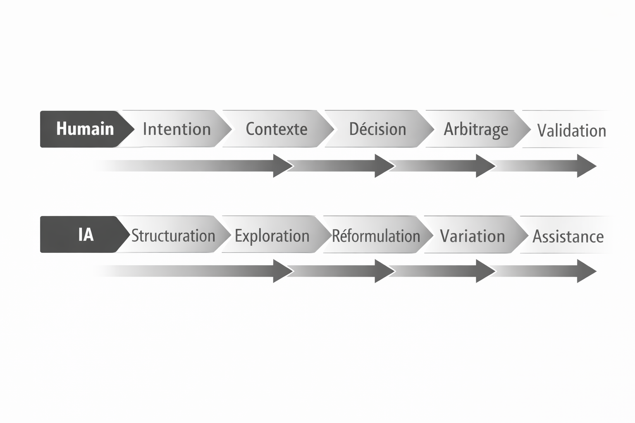
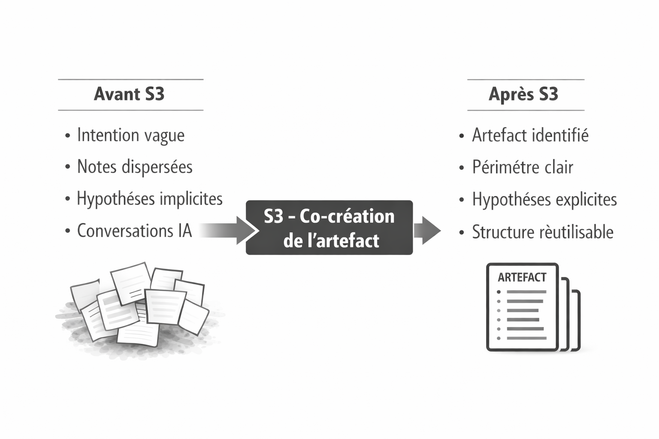

Chapter 7 — S4: Validation
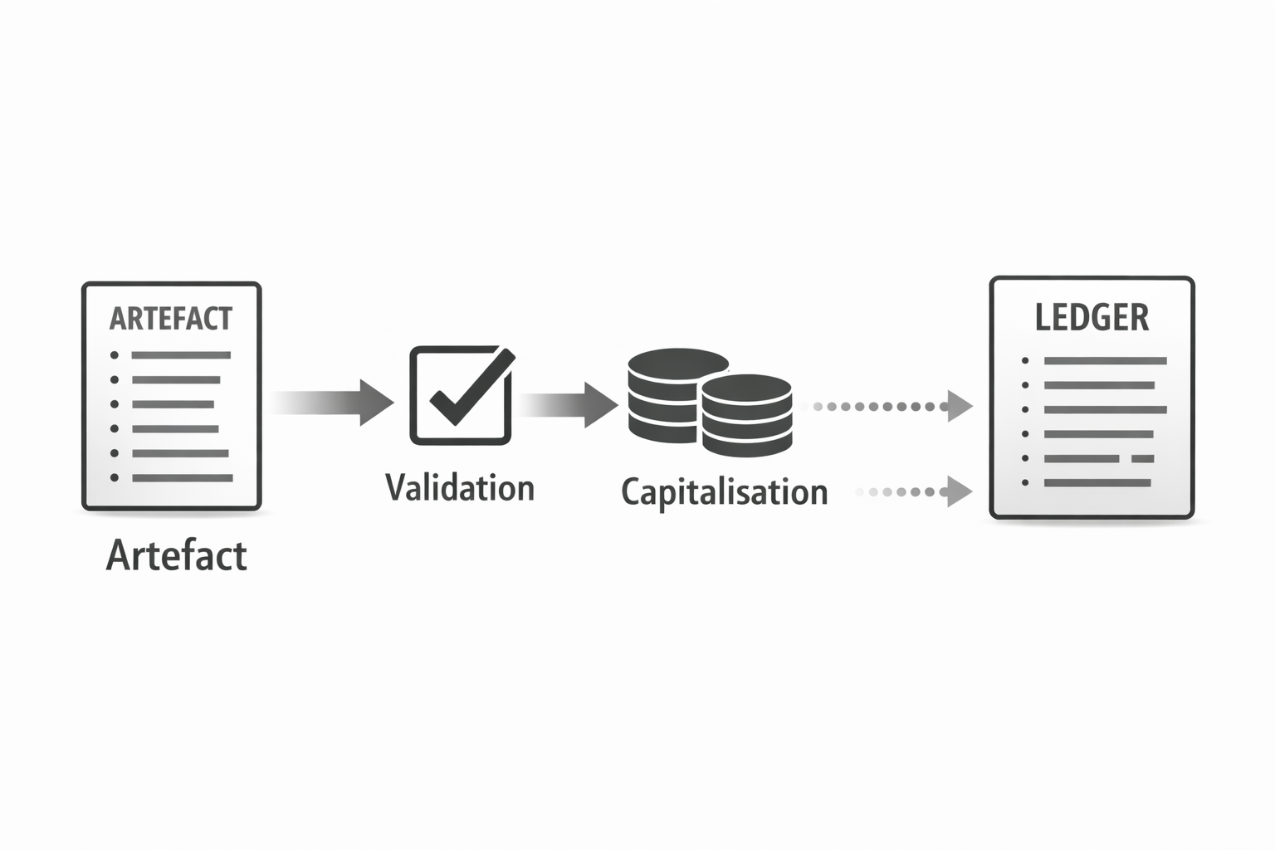
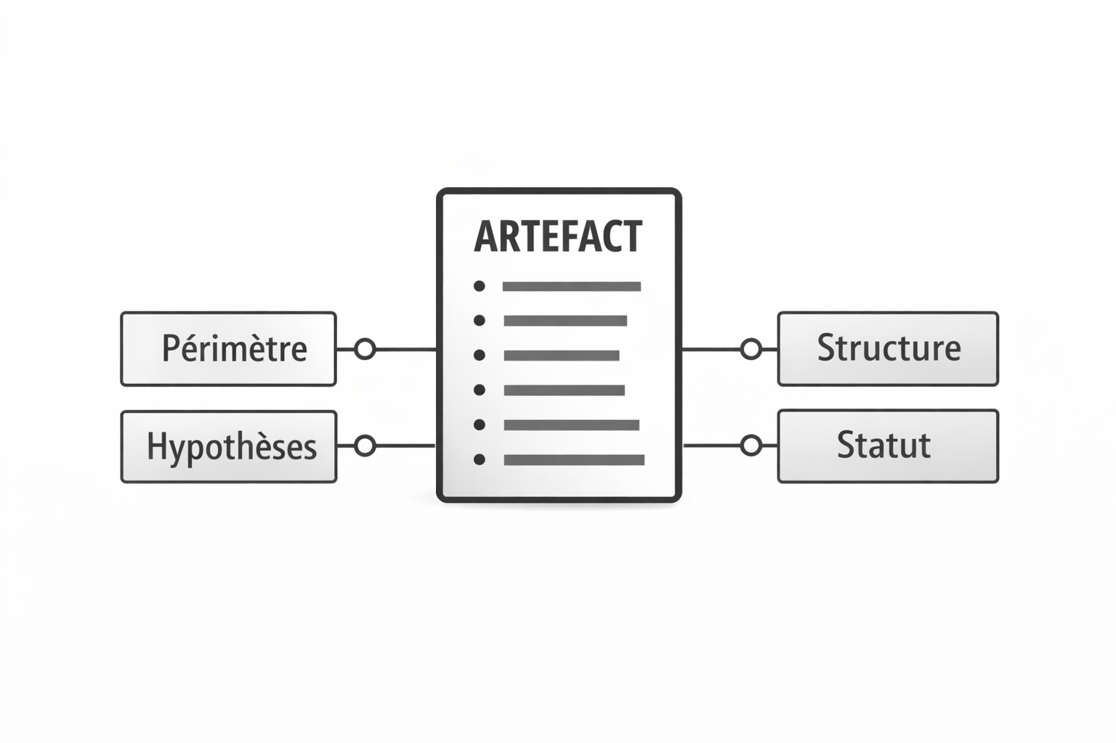

S4, the stage everyone skips
In real life, we tend to confuse:
- positive impression (it looks good, it is well written)
- real validation (it works in our context)
S4 formalises the moment when we test seriously:
- Is it usable?
- Is it understandable by the right people?
- Is it robust across several scenarios?

Mini-example S4 (integrated literally)
The validation agent tests the procedure across three scenarios (Julie, rushed manager, junior profile).
Two weaknesses emerge: first-day overload + lack of clarity around “who is responsible”.
Adjustments proposed → integrated → status: Validated (Pro level).
S4 achieved

Defining the test scenarios
For Julie, the scenarios could be:
- Julie – experienced profile
  - expects a degree of autonomy;
  - wants to understand the culture and expectations
- Rushed manager.
  - has 30 minutes in the week to prepare the onboarding
  - cannot read a 20-page document
- Junior profile
  - has never worked remotely
  - needs explicit reference points
Each scenario becomes a test matrix
- does the document allow this profile to achieve their objective?
- where are the frictions?
- what information is missing?

Role of the validation agent
The validation agent can:
- simulate the reading experience for each profile
- play out dialogues (questions asked, possible answers)
- spot logical inconsistencies
- propose targeted improvements
For example:
- The first day contains 14 different actions, which risks being unrealistic; suggestion: spread them over 3 days
- Responsibility for creating access is assigned to no one; propose a roles table

Validation decision
At the end of S4, you must be able to record:
- Status:
  - Validated (Pro level)
  - Validated (light or experimental version)
  - To be reworked before a new validation attempt
- Conditions:
  - To be reviewed after 3 onboardings
  - Reserved for experienced profiles
  - Pending validation by the HR team
- Planned review date
The ledger records:
- the scenarios
- the observations
- the decision
- the changes made

Mini-checklist for your own validations
For your next artefact:
- Define at least two real usage scenarios
- Ask the AI to simulate these scenarios with your document
- List:
  - what blocks progress
  - what is missing
  - what is redundant
- Apply the corrections
- Give the version an explicit status (even if it is “Version 0.8, provisional”)
You are then doing an S4, even in simplified form.

Chapter 8 — S5: Capitalisation and iteration
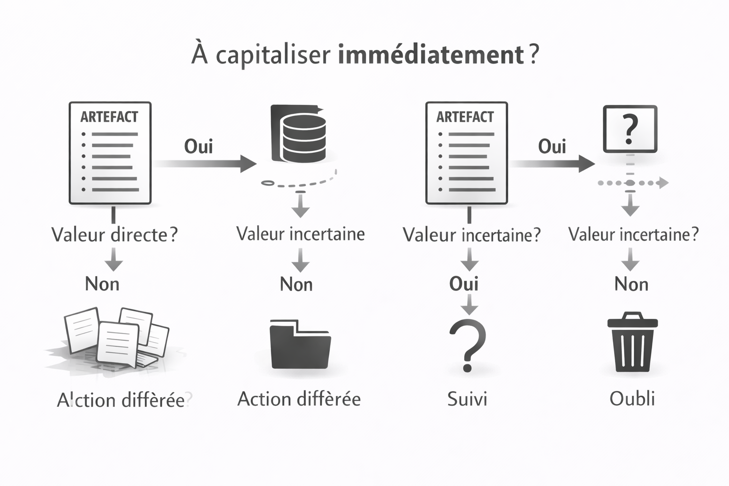

The risk of the “orphan document”
Without S5, the artefacts produced risk:
- getting lost in obscure folders
- being duplicated
- not being updated
- no longer being understood 6 months later
S5 answers three questions:
- Where do we store what has been produced
- How do we make it findable and understandable
- How do we improve it over time

Mini-example S5 (integrated literally)
The procedure is placed in the memory ecosystem, with v1.0.
A summary is added to the documentation.
Field feedback after 30 days → two issues identified:
- lack of systematic access checks
- lack of mentoring
This feedback becomes a new entry in the ledger.
A new S1 idea is opened to prepare V2.
S5 closes the cycle and initiates the next iteration.

Three layers of capitalisation
- The final artefact
  - onboarding procedure v1.0
  - available in a shared space
- The documentation
  - summary sheet (What is this procedure for)
  - user guide (Who should use it, When, How)
- The ledger
  - version history
  - decision contexts
  - field feedback and iteration decisions

From the field to the new S1
After 30 days, the company observes:
- some access is still being forgotten → the procedure assumed that IT never forgets
- Julie feels a little isolated → a structured mentoring component is missing
Rather than patching things at the margins, these findings become:
- an S1 entry for Onboarding V2
- a reason to go back through S2→S3→S4→S5
In this way, each version improves on the previous one, within a documented cycle

How to set up S5 in your organisation.
- Choose a single repository
Notion, Confluence, structured Google Drive… it does not matter, but only one place
- Standardise procedure sheets
Always with at least:
  - objective
  - target audience
  - date of last validation
  - owner
- Connect the repository to the ledger
Each procedure has an SCV ID
The ledger tells its story.
- Establish an iteration ritual
(Quarterly, for example):
  - list of critical procedures
  - review of field feedback
  - selection of those that go back into re-S1

Chapter 9 — Separating the LLM from the decision agent
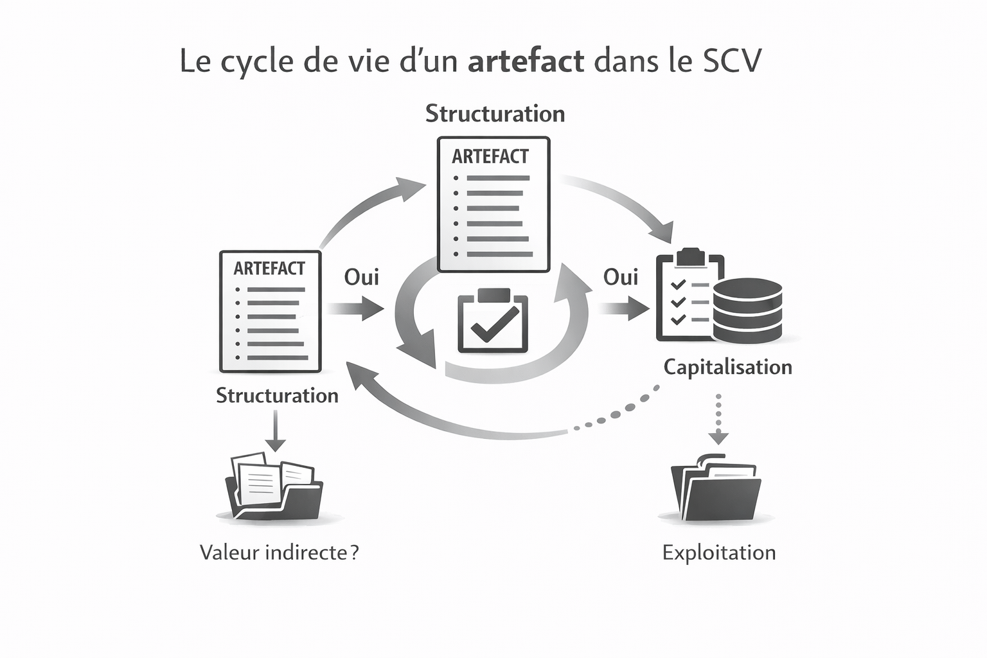

The danger of the friendly black box
When you ask an LLM: What would you recommend?
You get a plausible, reasoned, well-formulated answer.
The danger is taking it as a decision,
Yet:
- the model has neither responsibility, nor long-term context, nor stable memory
- you cannot easily audit why it answered that
- two identical calls, in different contexts, can produce divergent answers
SCV therefore proposes a clear separation:
- the LLM: interface (explanation, formatting, generation, simulation)
- the decision agent: explicit structure (tables, rules, matrices, thresholds)

Mini-example integrated literally
The LLM clarifies the information about Julie
A decision table is co-constructed:
- rows: characteristics
- columns: decisions (mentor, training, meeting frequency)
The table becomes the decision agent.
The LLM serves as the explanatory interface.
The decision is no longer in the model’s head but in an explicit structure.

Building a decision table for mentoring
For example, to decide how often Julie should meet with her mentor, you can build a table:
- Rows – Characteristics
  - remote work experience (low / medium / high)
  - seniority (junior / intermediate / senior)
  - role complexity (low / medium / high)
- Columns – Decisions
  - mentor required? (yes/no)
  - mentor profile
  - meeting frequency (weekly / fortnightly / monthly)
  - duration of support (30 / 60 / 90 days)
The LLM helps to:
- propose rules
- suggest combinations
- explain possible implications
But the final structure is stabilised in a table that is readable and shareable.

Advantages of this separation.
- Auditability
You can show the table to an auditor, a manager, or HR
- Human alignment
The whole team can discuss the visible rules, rather than trusting the AI
- Controlled evolution
If you change AI tools, the table remains
You do not lose your decision logic
- Clear responsibility
The decision is not the AI’s, but yours, embodied in an artefact

Application: your first simple decision agent
Choose a case:
- prospect prioritisation
- choice of a communication channel
- decision to issue a customer refund, etc.
- List the characteristics (rows)
- List the possible decisions (columns)
- Ask the AI:
  - to help you fill in the table
  - to suggest rules
  - to simulate cases
You have just turned an LLM into an assistant… in the service of an explicit decision agent.

Chapter 10 — SCV-Ledger: immutable log of decisions
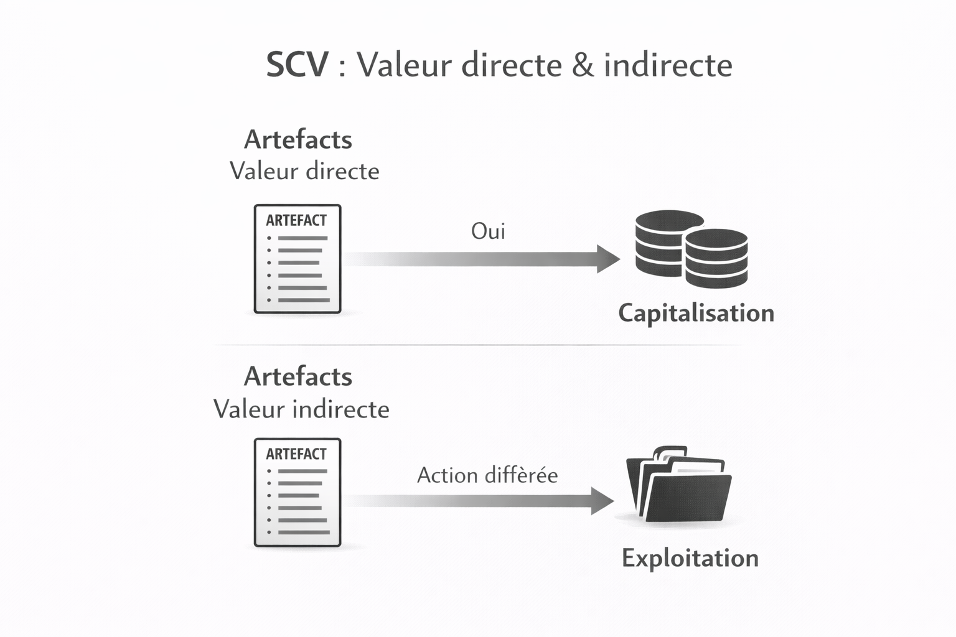

Why a ledger?
For SCV, the ledger is what the logbook is to the pilot:
it does not fly in the pilot’s place, but it keeps a record of:
- what happened
- when
- with which decisions
In an AI environment, the ledger makes it possible to:
- reconstruct the chain of decisions
- understand why a procedure is where it is
- reassure stakeholders (management, legal teams, clients)

Mini-example integrated literally
For SCV-2025-11-20-0001, the ledger contains:
- S1 Entry — captured idea
- S2 Entry — structured mandate
- S3 Entry — prototype
- S4 Entry — validation
- S5 Entry — field feedback
The ledger makes it possible to reconstruct the entire journey: rationale, decisions, versioning, learnings.

Structure of a ledger entry
A typical entry could contain:
- SCV ID: SCV-2025-11-20-0001
- Stage: S3
- Date: 2025-11-22
- Actors:
  - human: Manager
  - AI agents: Co-creation_Onboarding_v1
- Summary:
Creation of two versions (A structured, B narrative) + combined prototype
- Decisions:
Keep structure A, integrate pedagogy from B, simplify checklists
- Next action:
Move to S4 – validation across 3 scenarios

Where should the ledger be stored?
Depending on your size:
- small structure / freelancer: a Notion database or a structured spreadsheet is sufficient
- team / SME: a dedicated database (Airtable, internal DB)
- large organisation: integration into an AI governance or GRC tool
What matters is that:
- each SCV ID has a unique timeline
- entries are easy to browse
- you can filter by
  - stage
  - status
  - owner
  - date

The ledger as a steering tool
In practice, you will be able to:
- see how many projects are in S2, S3, S4, S5
- identify bottlenecks
- prioritise validations
- track the increase in the number of validated artefacts
This is where SCV becomes an operational dashboard for your human–AI symbiotic

Chapter 11 — Summary + Immediate application.

Julie’s common thread, one sentence per stage
A fuzzy idea (we really need to improve our onboardings), captured as a voice memo, became a clear, tested, versioned onboarding procedure, supported by a decision table and entered into a ledger.
- S1: voice memo → SCV-2025-11-20-0001 entry
- S2: short dialogue → structured onboarding mandate
- S3: two versions of the procedure → combined, metadata-enriched prototype
- S4: test across three scenarios → adjustments → “validated_pro” status
- S5: storage, documentation, field feedback → new S1 for V2
The same pattern applies to:
- a quality procedure
- a training module
- a sales playbook
- an internal decision support tool

SCV maturity levels

Maturity 1 — “light” SCV
- You have:
  - a simple S1 (a single inbox)
  - the beginnings of S2 (clearer mandates)
  - a somewhat structured S3
- Validation often remains informal.
- The ledger is embryonic (a few notes).
This is already a major leap compared with improvised chat use

Maturity 2 — operational SCV
- S1 → S5 are systematic on important projects
- Key decisions are versioned and traceable
- The ledger becomes a steering instrument
- Several people in your organisation master SCV

Trilingual reminder
SCV works natively in FR/EN/ES
- capture in French
- co-structuring in English
- bilingual final artefact
- documentation in Spanish
… without changing method, only language.
This is a decisive advantage for:
- distributed organisations
- international teams
- multilingual contexts (Canada, Europe, Latin America…)

7-day action plan
To turn this book into practice, you can set yourself a micro-plan:
- Day 1 – Choose and configure your S1 (channel + identifiers)
- Day 2 – Formalise your first S2 mandate on a real topic
- Day 3 – Launch an S3 with two artefact versions + prototype
- Day 4 – Build an initial S4 by defining two test scenarios
- Day 5 – Create a simple base for your ledger (Notion, spreadsheet)
- Day 6 – Connect a validated artefact to your document repository
- Day 7 – Organise a short review (alone or as a team) to decide the next S1

And now?
You now have:
- a mental framework (SCV)
- a concrete common thread (Julie)
- practical tools (mandates, scenarios, decision tables, ledger)
- an adaptable trilingual method
The logical next step can be:
- to apply SCV to
  - your sales
  - your quality processes
  - your training
  - your product decisions
- to equip SCV in a dedicated application
- to train your team to think in SCV rather than in isolated prompts
This first volume deliberately focuses on the framework and Julie’s common thread. A second volume could explore a variety of use cases in detail (sales, quality, training, product), including in fully multilingual contexts, showing how the same SCV flow produces different “shovels” depending on the profession.

Appendix — SCV Glossary

Core SCV concepts
SCV
- FR: SCV – Symbiotic Creation & Validation
- EN: SCV – Symbiotic Creation & Validation
- ES: SCV – Creación y Validación Simbiótica
- Methodological framework for turning a fuzzy idea into a clear, validated, and reusable result through a structured five-stage flow (S1→S5) and governed human–AI collaboration.
SCV flow
- FR: flux SCV
- EN: SCV flow
- ES: flujo SCV
- Complete sequence S1→S2→S3→S4→S5, from the capture of an idea to its capitalisation.
S1 – Symbiotic capture of ideas
- FR: S1 – Capture symbiotique des idées
- EN: S1 – Symbiotic capture of ideas
- ES: S1 – Captura simbiótica de ideas
- Single entry point where all ideas, even fuzzy or poorly formulated ones, are deposited and assigned an SCV ID.
S2 – Co-Structuring
- FR: S2 – Co-Structuration
- EN: S2 – Co-Structuring
- ES: S2 – Coestructuración
- Stage in which the co-structuring agent and the human turn the raw idea into a structured mandate (objectives, context, constraints, assumptions, success criteria).
S3 – Co-Creation of the artefact
- FR: S3 – Co-Création de l’artefact
- EN: S3 – Co-Creation of the artefact
- ES: S3 – Cocreación del artefacto
- Production of artefact versions, often from several angles, followed by trade-off decisions towards a testable prototype.
S4 – Validation
- FR: S4 – Validation
- EN: S4 – Validation
- ES: S4 – Validación
- Testing of the artefact against concrete scenarios, identification of weaknesses, adjustments, then explicit decision-making.
S5 – Capitalisation and iteration
- FR: S5 – Capitalisation et itération
- EN: S5 – Capitalisation and iteration
- ES: S5 – Capitalización e iteración
- Archiving the validated artefact, documenting it, recording learnings in the SCV-Ledger, and possibly opening new iterations.
Artefact
- FR: artefact
- EN: artefact
- ES: artefacto
- Concrete result of an SCV flow: procedure, document, script, playbook, decision table, training module, etc.
Testable prototype
- FR: prototype testable
- EN: testable prototype
- ES: prototipo testeable
- Artefact version produced in S3, sufficiently advanced to be tested in S4.
Human–AI symbiotic
- FR: symbiose humain–IA
- EN: human–AI symbiotic
- ES: simbiosis humano–IA
- The human retains responsibility for meaning, context, and decision; AI brings volume, structuring, and variation.

Roles, agents, and models
LLM
- FR: LLM (modèle de langage de grande taille)
- EN: LLM (Large Language Model)
- ES: LLM (Modelo de Lenguaje de Gran Tamaño)
- Generative AI model used to generate, reformulate, explain, and simulate, but which does not carry the final decision.
Specialised AI agent
- FR: agent IA spécialisé
- EN: specialised AI agent
- ES: agente de IA especializado
- Specific configuration of an LLM dedicated to a task within the SCV flow.
Co-structuring agent (S2)
- FR: agent de co-structuration
- EN: co-structuring agent
- ES: agente de coestructuración
- Turns an S1 idea into a structured S2 mandate through questions, reformulations, and options.
Co-creation agent (S3)
- FR: agent de co-création
- EN: co-creation agent
- ES: agente de cocreación
- Produces different versions of an artefact from the S2 mandate, then assembles a prototype in line with human trade-offs.
Validation agent (S4)
- FR: agent de validation
- EN: validation agent
- ES: agente de validación
- Simulates the use of the artefact on test scenarios and proposes corrections.
Capitalisation agent (S5)
- FR: agent de capitalisation
- EN: capitalisation agent
- ES: agente de capitalización
- Helps document decisions, structure field feedback, and create the corresponding entries in the SCV-Ledger.
Explanation agent / LLM interface
- FR: agent d’explication (interface LLM)
- EN: explanation agent / LLM interface
- ES: agente de explicación / interfaz LLM
- Conversational interface used to explain artefacts, decision tables, and statuses, without carrying the decision logic.
Decision agent
- FR: agent de décision
- EN: decision agent
- ES: agente de decisión
- Explicit structure (tables, rules, matrices) that encodes decisions. The LLM can explain or execute it, but the logic is in the structure.

Mandates, scenarios, and statuses
S2 mandate
- FR: mandat S2
- EN: SCV mandate (S2 mandate)
- ES: mandato SCV (mandato S2)
- Short document that formalises the objective, target audience, context, constraints, assumptions, and success criteria of an artefact.
Test scenario
- FR: scénario de test
- EN: test scenario / use case scenario
- ES: escenario de prueba / caso de uso
- Concrete situation on which an artefact is tested during S4.
Validation status
- FR: statut de validation
- EN: validation status
- ES: estado de validación
- Label applied to an artefact version after S4 (e.g. Validated (Pro level), Validated (light version), To be reworked).
Quality level
- FR: niveau de qualité (ex. “niveau Pro”)
- EN: quality level (e.g. “Pro level”)
- ES: nivel de calidad (p. ej. “nivel Pro”)
- Qualitative indication reflecting the level of rigour achieved.

SCV-Ledger, memory, and identifiers
SCV-Ledger
- FR: SCV-Ledger
- EN: SCV-Ledger
- ES: SCV-Ledger (or libro mayor SCV)
- Structured log recording all important stages of an SCV ID: S1, S2 mandate, S3 prototypes, S4 validations, S5 capitalisation, field feedback, decisions, versions.
Ledger entry
- FR: entrée de ledger
- EN: ledger entry
- ES: entrada de ledger
- Single record in the SCV-Ledger, associated with an SCV ID and a given stage.
SCV ID
- FR: ID SCV
- EN: SCV ID
- ES: ID SCV
- Unique identifier of an SCV flow, generally in the form SCV-YYYY-MM-DD-XXXX.
Version
- FR: version (ex. v0.3, v1.0)
- EN: version
- ES: versión
- Iteration indicator for an artefact within an SCV flow.
Memory ecosystem
- FR: écosystème mémoire
- EN: memory ecosystem
- ES: ecosistema de memoria
- Set of spaces where artefacts, procedures, documents, summaries, and the SCV-Ledger are stored.

Tables and decisions
Decision table
- FR: tableau de décision
- EN: decision table
- ES: tabla de decisión
- Tabular structure used to encode rules: rows = characteristics, columns = decisions.
Decision rule
- FR: règle de décision
- EN: decision rule
- ES: regla de decisión
- Explicit condition linking a combination of characteristics to an action.

Metaphor and narrative language
AI gold rush
- FR: ruée vers l’or IA
- EN: AI gold rush
- ES: fiebre del oro de la IA
- Metaphor for the current context: many AI tools, actors, and excitement, but little operating method.
Shovels / custom shovels
- FR: pelles / pelles sur mesure
- EN: shovels / custom shovels
- ES: palas / palas a medida
- “Shovels” = concrete tools (prompts, AI agents, workflows, tables, procedures). “Custom shovels” = tools designed specifically for a context or profession.
Shovel factory
- FR: fabrique de pelles
- EN: shovel factory
- ES: fábrica de palas
- Image used to describe SCV as an AI tool factory: from the same flow, different monetisable artefacts are produced.

Multilingual
Natively multilingual
- FR: multilingue natif
- EN: natively multilingual
- ES: multilingüe nativo
- The SCV flow does not depend on language. You can capture in FR, structure in EN, produce in FR/EN, document in ES, without changing method.
Multilingual SCV flow (canonical example)
- FR: S1 en français → S2 en anglais → artefact S3 bilingue FR/EN → documentation/ledger en espagnol.
- EN: S1 in French → S2 in English → S3 artefact in FR/EN → documentation/ledger in Spanish.
- ES: S1 en francés → S2 en inglés → artefacto S3 bilingüe FR/EN → documentación/ledger en español.
- Standard example illustrating the multilingual nature of SCV.

SCV maturity
SCV maturity
- FR: maturité SCV
- EN: SCV maturity
- ES: madurez SCV
- Level of adoption of SCV within an organisation, from “light” SCV to operational SCV.
“Light” SCV
- FR: SCV “light”
- EN: “light” SCV
- ES: SCV “ligero”
- Partial use of the framework (S1, S2, S3 in place, less formalised validation, embryonic ledger).
Operational SCV
- FR: SCV opérationnel
- EN: operational SCV
- ES: SCV operacional
- Full implementation of the S1→S5 flow, with SCV-Ledger, defined agents, iteration rituals, and tangible impacts on decisions and processes.

